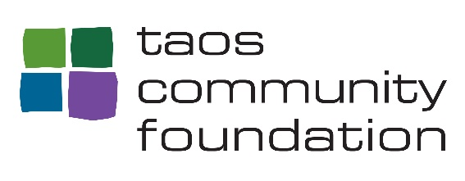
Leonard and Jane Lecht Legacy Scholarship Fund
Application – 2021

Personal Information

Full Name ___________________________________________________________

Mailing Address:

____________________________________________________________________
Phone #: _______________________ E-Mail (if any): ________________________

Current Employment Information

How long have you been employed with Taos Retirement Village?
____________________________

What is your current job/position/title?
___________________________________________________
How many hours do you currently work at Taos Retirement Village? _______________

Educational Information:
Last School Attended: ___________________________________________________________________

Date of HS Graduation (or) Date of GED Certification: ________________________
Highest Level of Education achieved as of this application:
___________________________________________________________________________
If in a current course of study, please share:

Credits Earned ____________, and towards ____________________ (degree or certification).
Please list any/all post High School academic/professional training programs you have attended:
____________________________________________________________________________
____________________________________________________________________________
Educational Goals at time of Application:
Name of educational program that you are currently attending/hoping to enroll in:
____________________________________________________________________________

Please share with us why this is the best program choice for you at this time:

____________________________________________________________________________

____________________________________________________________________________

Anticipated enrollment date:
___________________________________________________________

Possible Major/Certificate/Field of Study:

______________________________________________________________________

Volunteer and/or Community Involvement:
______________________________________________________________________

______________________________________________________________________

______________________________________________________________________

Professional / Personal Accomplishments you would like us to know about: ______________________________________________________________________

_____________________________________________________________________

______________________________________________________________________

_____________________________________________________________________

Attachments
- Please attach a personal essay (no more than 2 pages) focusing on one of the two topics:
  - How will completing this course further advance your work/professional experience?
  - How has your educational experience contributed to who you are today?
- Please attach a one page personal resume
- Please include an Unofficial Copy of your highest educational program completed (HS diploma, GED or HSE, etc.)
- Please DO NOT include copies of Personal Recommendations or Reference Letters

Scholarship recipients will be notified by email/ mail of the award.
Applications must be received or postmarked by May 28th 2021 by 4pm

Applications should be sent to Helen Forte at the address below.
For additional information, please contact:

Helen Forte
Director of Community Outreach
Taos Community Foundation
(575) 737-9300
hforte@taoscf.org

Mailing Address: Taos Community Foundation, PO Box 1925 Taos NM 87571

Physical Address: 117 La Posta Road, Suite A, Taos NM 87571

