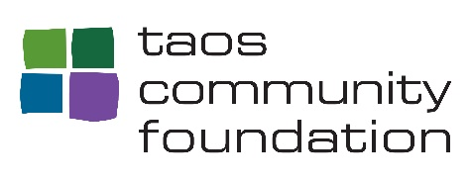
WE ALL COUNT!
SUPPORT THE 2020 CENSUS
WHY ARE NONPROFITS KEY TO A FAIR AND ACCURATE COUNT?
Location: Nonprofits are densely located in traditionally undercounted areas.
Access: Nonprofits have everyday contact with communities most at risk of being undercounted. Without inventing a new program, nonprofits can provide basic information to the thousands who pass through their doors on how and why to participate in the census.
Trust: Nonprofits have trusting relationships with the communities they serve and can act as powerful vehicles for education about the importance of census participation. When the message to be counted comes from a trusted entity, people are more likely to participate.
Multilingual: Nonprofits connect to a range of constituencies and cultures. Most nonprofits serving communities who speak languages other than English can provide access to census education materials in their communities’ languages.
Visibility: Nonprofits are out in the community at events, meetings and everywhere people live, work, and play.
A Vested Interest: Nonprofits driven by social missions have an inherent interest in ensuring that their communities have access to the funds, services, representation, and physical and social infrastructure impacted by the census count.

WHAT WILL YOU DO TO MAKE SURE THAT EVERYONE IS COUNTED?

SEE BELOW FOR 10 SUGGESTED ACTIVITIES FOR GETTING OUT THE COUNT
Complete 3 of the activities listed below – or any others you choose,
and return the completed form (also available on our website) by
September 15, 2020 to be entered in the raffle draw for a $1,000.00 grant!

For more information on the role of nonprofit organizations in the 2020 census,
visit nonprofitvote.org

PO Box 1925 Taos, NM 87571 | 575 -737 -9300 | hforte @ t a o s c f . o r g | taoscf.org

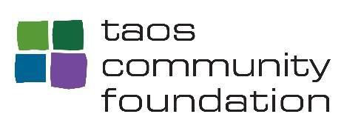
Choose 3 or more activities. Include date and description for each activity in the space provided.

NONPROFIT ORGANIZATION CENSUS ACTIVITIES FORM
ORGANIZATION NAME_____________________________________ CONTACT_____________________

- Educate yourself and your coworkers about the census and why it matters to those you serve.
For more information. https://2020census.gov/en/what-is-2020-census.html

- Develop and share awareness materials to promote the census in your work.
For outreach materials. https://2020census.gov/en/partners/outreachmaterials

- Add the awareness materials and targeted messaging to your website.

- Advertise U.S Census Bureau job opportunities.
Job Opportunities. https://2020census.gov/en/jobs

- Promote the importance of the census at meetings with other agencies, Non-Profit organizations and community leaders.

- Co-sponsor a community event on the census.

- Promote the census in e-communications/social media.
Social Media Graphics https://www.census.gov/partners/2020-materials/social- media-graphics.html

- Incorporate the census in all ongoing outreach, services, and advocacy.

- Distribute printed census materials to your clients. Print materials. https://2020census.gov/en/partners/outreach-materials.htm

- Provide computers and phones for people to use when completing the census.

PO Box 1925 Taos, NM 87571 | 575 -737 -9300 | hforte @ t a o s c f . o r g | taoscf.org

