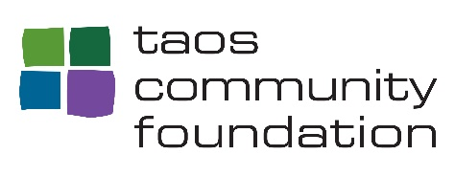

WE ALL COUNT!
SUPPORT THE 2020 CENSUS
WHY ARE BUSINESSES KEY TO A FAIR AND ACCURATE COUNT?
WHAT WILL YOU DO TO MAKE SURE THAT EVERYONE IS COUNTED?
See below for suggested activities for getting out the count.
Complete 3 or more of the activities listed below by September 15, 2020 and
return the completed form to Taos Community Foundation to be entered in the raffle draw!
Email the form to hforte@taoscf.org or drop it in the mail to:
Taos Community Foundation PO Box 1925 Taos, NM 87571
You could win a $1,000 grant to support a local nonprofit organization!
For more resources, and information on the role of businesses in the 2020 census,
visit 2020Census.gov, icountnm.gov, and nmcounts2020 or
https://www.strongnation.org/readynation/2020-census.

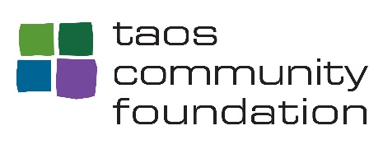

BUSINESS CENSUS ACTIVITIES FORM
ORGANIZATION NAME ________________________________
CONTACT ___________________________________________
- Educate yourself and your coworkers about the census and why it matters to those you serve. Send out the information in an employee email or newsletter.
For more information https://2020census.gov/en/what-is-2020-census.html
_________________________________________________________________________________
- Develop and share awareness materials to promote the census. Display them in your place of business.
For outreach materials https://2020census.gov/en/partners/outreachmaterials
_________________________________________________________________________________
- Add the awareness materials and targeted messaging to your website.
_________________________________________________________________________________
- Advertise U.S Census Bureau job opportunities.
Job Opportunities https://2020census.gov/en/jobs
_________________________________________________________________________________
- Promote the importance of the census at employee gatherings.
_________________________________________________________________________________
- Be a sponsor of a virtual community event on the census.
_________________________________________________________________________________
- Promote the census in e-communications/social media for customers.
Social Media Graphics https://www.census.gov/partners/2020-materials/social- media-graphics.html
_________________________________________________________________________________
Choose 3 or more activities. Include date and description of each in the spaces provided.
Deadline September 15, 2020

