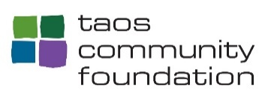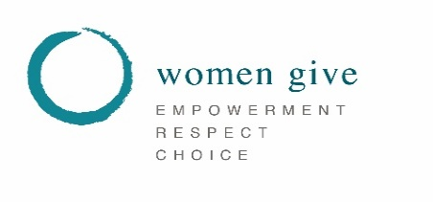

Women Give Taos Grant Announcement – 2018-19

Taos Community Foundation is pleased to announce the Women Give Taos Impact Grant opportunity for 2018-19. Eligible Non Profit Organizations serving Women and Girls in Taos and Western Colfax Counties are invited to apply for funding to support project proposals meeting one or more of the WGT priorities (see below). Awards will be in the range of $10,000 to $30,000. Applications will be reviewed by the WGT Grants Committee for funding consideration and grant award recommendations.
Please note: Applying for and/or receiving this Grant does not preclude application to other TCF funding opportunities.
Grants can be awarded to qualified 501(c) (3) nonprofit organizations, federally-recognized Indian tribes, public schools, and governmental agencies. Grants cannot be made to individuals.
Instructions for completing and submitting the application
Applications must address one or more of the Women Give Taos Impact Grant Application 2018 -19 priorities listed below. These are all issues significantly impacting Women and Girls in our community.
- Life Skills /Employment, parenting, preparation and training
- Access to Educational Opportunity
- Emotional and physical health ( include addiction and teen pregnancy)
- Healthy development and personal authority of young girls
- Violence - societal and domestic
Elements for Preparing a Grant Submission

1) Proposal Coversheet – This will be page (1) one of the submission. This document may be hand-written. (Clearly printed and legible) Please make sure all lines are complete.

2) Proposal– Pages 2, 3 & 4 of the submission. Please use the following guidelines for the Proposal section:
- no more than three single-spaced 8.5x11-inch pages
- margins of no less than one inch
- type size of no less than 12 points
- Be sure to answer all the questions completely.
The proposal should clearly identify the WGT priority (ies) addressed in your application. In your answers to the questions, please provide a clear overview of the activities/programs your organization intends to provide to address these priorities.
- Which WGT funding priority (ies) are you addressing?
- Clearly outline the community need or issue addressed by your proposal and the population(s) who benefit.
- Describe your action plan for addressing this need. How does your proposal meet one or more of the WGT funding priorities?
- What are the root causes, policies and other structural barriers affecting this issue, and how is your organization working towards addressing these barriers?
- How are the people most affected by the issue you are addressing informed, involved, and represented in your organization’s program development, decision making, and outreach?
- Is collaboration with other agencies anticipated? If so, please include the partner-agencies and provide a brief summary of the roles of each partner within the project.
- Is this a time-sensitive project? If so, please outline the start and estimated completion dates
- What is the desired outcome or results to be achieved?
- How many individuals do you anticipate serving?
- How will outcomes be measured? (Results Based Accountability)
- Summarize your request.

3) Financial information Page–Page 5. Please provide the following information and a narrative statement if additional information seems important to highlight:
- What is the organization’s total operating cost?
- If project related, what is the total cost of the specific project?
- Is there other funding currently in place for the project?
- If so, what is the amount and source of that funding?
- How would this grant funding enhance your work?

4) Non-Profit Documentation / Signature Page – This will be the final page of the submission. (Page 6)
- Please do not include newsletters, photographs, or marketing material as supplements to your submission.
Deadline and Submission Instructions
Applications should only be submitted by email transmission, in a PDF format. Submissions will not be accepted in hard-copy or fax, unless previously approved by TCF. Only one application may be submitted per organization during the open submission time period.
The deadline for submission is: Thursday, January 31, 2019 by 4:00 PM.
Please submit to the following email address: hforte@taoscf.org
Deliberation/ Notification
Applications will be reviewed by the Foundation's WGT Grants Committee and Membership. Subsequently, selected applicants may receive a formal invitation to submit further information, if needed, which could include a request for a site visit. Applicants will be notified of decisions no later than April 7, 2019.
Organizations that have late/outstanding Final Grant Reports to TCF are not eligible to submit any applications for funding until all previous grant reporting requirements have been met, and all previous awarded grants are considered “Closed – In Good Standing”. As there may be some “overlap” in the deadline for an existing grant and this current deadline, organizations wishing to discuss this further are encouraged to contact Helen Forte, Director of Community Outreach,(575)737-9300 or hforte@taoscf.org for additional clarification.

